Report On

Hotel Management System

Submitted in partial fulfillment of the requirements of the Course project in

Semester V of Third Year Computer Engineering

by

Vipul Bhoir (Roll No. 07)

Mrudul Chaudhari (Roll No. 12)

Abhinav Desai (Roll No. 14)

Mentor

Prof. Anil Hingmire



**University of Mumbai**

**Vidyavardhini's College of Engineering & Technology**

**Department of Computer Engineering**



**(A.Y. 2023-24)**

**Vidyavardhini's College of Engineering & Technology**

**Department of Computer Engineering**

**CERTIFICATE**

This is to certify that the Course Project entitled **“Hotel Management System”** is a bonafide work of "Vipul Bhoir (Roll No. 07), Mrudul Chaudhari (Roll No. 12), Abhinav Desai (Roll No. 14)"submitted to the University of Mumbai in partial fulfillment of the requirement for the award of the degree of **“Bachelor of Engineering”** in Semester V of Third Year **“Computer Engineering”.**

|  | ______________________  Prof. Anil Hingmire  Mentor |  |
| --- | --- | --- |
| ________________ |  | _______________ |
| Dr Megha Trivedi  Head of Department |  | Dr. H.V. Vankudre  Principal |

**Vidyavardhini's College of Engineering & Technology**

**Department of Computer Engineering**

# Course Project Approval

This Course Project entitled **“Hotel Management System”** by Vipul Bhoir (Roll no.07), Mrudul Chaudhari (Roll no.12), Abhinav Desai (Roll no.14)is approved for the degree of **Bachelor of Engineering** in in Semester V of Third Year **Computer Engineering.**

**Examiners**

**1………………………………………**

(Internal Examiner Name & Sign)

## 2…………………………………………

(External Examiner name & Sign)

Date: Place:

# Contents

# Abstract ii

## Acknowledgments

###### Chapter 1:  Introduction

1.1 Introduction

1.2 Problem Statement

1.3 Scope of the project

**Chapter 2:** **Requirement Analysis**

2.1Hardware & Software

2.2 Functional Requirement

2.3 Non-Functional Requirement

###### Chapter 3: System Design

3.1 Abstract view of the system

3.2 Detailed design

3.3 Module description

**Chapter 4:** **Implementation**

4.1 Methodology

4.2 Sample module program code

**Chapter 5:** **Result**

5.1 Result

**Chapter 6:** **Conclusion**

6.1 Conclusion

6.2 References

**Abstract**

The Project Hotel Management System is a web based application that allows the hotel manager to handle all hotel activities online. Interactive GUI and the ability to manage various hotel bookings and rooms make this system very flexible and convenient. The hotel manager is a very busy person and does not have the time to sit and manage the entire activities manually on paper. This application gives him the power and flexibility to manage the entire system from a single online system. The Hotel Management project provides room booking, staff management and other necessary hotel management features. The system allows the manager to post available rooms in the system. Customers can view and book room online. Admin has the power of either approving or disapproving the customer's booking request. Other hotel services can also be viewed by the customers and can book them too.

**Acknowledgement**

Apart from the efforts of me, the success of any project depends largely on the encouragement and guidelines of many others. I take this opportunity to express my gratitude to the people who have been instrumental in the successful completion of the project.

I would like to thank Mr. Anil Hingmire Sir for their tremendous support and help .Without their encouragement and guidance this project has not materialized. The guidance and support received from all the members who contributed and who are contributing to this project was vital for the success of the project. I am grateful for their constant encouragement and help.

We are thankful to our principal Dr. Harish Vankudre Sir for providing different facilities .We also express our gratitude to Dr. Megha Trivedi (Head of the Department) for her help , support and valuable time whenever required.

We are thankful to all the faculty members of our project for giving their valuable suggestions, knowledge to us which help us throughout the project.

**Introduction**

The main artifact of this project is to make a web based application which will make the management system run smoothly with a proper database system. The project allows the hotel employee to have an interactive GUI and can even manage the room's services and booking in a systematic manner. As the hotel employees are very busy people and do not have time to plan and manage everything on paper. Now he/she has the power to do it easily with flexible time from this project. The project will allow the hotel management to go on smoothly as it will have features such as Check-in, Check-out, restaurant bills and reservations. As all the important parties are stored on the application it is easy to make the bill of a guest and check the availability of the rooms beforehand. The data will be safe with only authorized people having access to the data.The data will also be safe and can be recovered if any natural disaster takes place the data can bere stored easily. Restaurant services are also provided here which make it easier when the guest checks out of the hotel. This system is useful both for the customer and the hotel employee which will have a good effect on both side of.

**Objective**

The main objective of this project is to design a hotel management system for running a hotel business. The system should be as flexible as possible so that it can be used for different hotels. You have to find out which procedures hotels have used for different hotels. You have to find out which procedures hotels have and based on that information, you should create a system which makes it efficient. You need to find out how a hotel system works on the internet, use your own experience or directly talk to people in the hotel business. The more diverse the sources of your information are, the better will be the resulting system and, possibly, your grade.

**Problem Statement**

To regulate a hotel is constantly a repetitive errand. The hospitality business, which runs on the sole motor of services, will undoubtedly conform to the nature of services to the visitors to leave a long lasting impression. The manual treatment of in the executive’s framework has consistently been a troublesome undertaking. Directing the littlest of the prerequisites of the visitors to the essential needs the hotel hospitality management need to place a great deal of vitality in controlling and executing the day-today work alongside the  different  things.

**Scope of the project**

**1.2.1 Existing System with Limitations:**

In this step, we provide a detailed description about the existing system and the problems faced in the existing system. This stage there is no existing system previously; we are developing a new system. Till now no system is available with this type of features and facilities. This system is developed for the all types of users with highly flexible and configurable product is envisaged to ensure global marketing

**1.2.2 Proposed System Features:**

Some of the service providers won't allow you to choose your hotel, they

only allow you to select the location and quality of the hotel. Considerable

discounts on hotels may be available in off-seasons. Utilize the serve of online hotel booking service providers when you are planning for a trip. Each and every customer looks to book their hotel rooms early and conveniently. User can Post, update and delete the links in all categories. Online hotel booking is the best ways to book rooms in your favorite

hotels. Planning a vacation has never been easier and more reasonable than now.

Easiness, affordable pricing, and simple comparison shopping make online

hotel bookings accepted to all.

**Hardware Requirements :**

The collection of internal electronic circuits and external physical devices used in building a computer is called the Hardware. The minimum hardware requirement specifications for developing this project are as follows:

Processor : Standard processor with a speed of 1.6 GHz

RAM : 256 MB RAM or more

Hard Disk : 20 GB or more

Monitor : Standard color monitor

**Software Requirements :**

A set of programs associated with the operation of a computer is called software. Software is the part of the computer system, which enables the user to interact with several physical hardware devices. The minimum software requirement specifications for developing this project are as follows:

Operating System : Windows 10/11

Presentation layer : Tkinter module of python

Database : My SQL

Documentation Tools : Ms Office

**Functional Requirements & Non- Functional Requirements**

**Functional Requirements**

Functional Requirements:

1. User Registration and Authentication:

- Users should be able to create accounts and log in securely.

2. Room Reservation:

- Users should be able to check room availability.

- Users should be able to book and cancel rooms.

- The system should provide room details and pricing.

3. Guest Check-In and Check-Out:

- Staff should be able to check guests in and out of rooms.

- Room status should be updated in real-time.

4. Billing and Payment:

- The system should generate and print bills for guests.

- It should support various payment methods (credit card, cash, etc.).

5. Room Maintenance:

- Staff should be able to mark rooms for maintenance.

- Maintenance requests should be tracked.

6. Staff Management:

- Admins should be able to add, modify, and delete staff accounts.

- Staff roles and permissions should be defined.

7. Reporting:

- Generate reports on occupancy rates, revenue, and other hotel metrics.

8. Inventory Management:

- Track and manage hotel supplies and inventory.

**Non-Functional Requirements**

The non-functional requirements of the Hotel Management System outline the qualities and characteristics that the system should exhibit in addition to its functional capabilities:

1. Performance:

- The system should respond quickly to user requests, even during peak usage.

2. Security:

- User data and payment information should be securely stored and transmitted.

- Access to sensitive functionality should be role-based.

3. Scalability:

- The system should be able to handle a growing number of users and rooms.

4. Reliability:

- The system should be available 24/7 with minimal downtime.

- Data should be regularly backed up.

5. Usability:

- The user interface should be intuitive and user-friendly.

6. Compatibility:

- The system should work on various devices and web browsers.

7. Compliance:

- Ensure compliance with data protection regulations (e.g., GDPR).

8. Integration:

- Ability to integrate with other systems (e.g., payment gateways, accounting software).

9. Accessibility:

- Ensure the system is accessible to users with disabilities.

**Discussion**

The Discussion is to facilitate easy management and administration of a hotel with capabilities to do Booking or reservations of the rooms, Cash billing, Room service, Restaurant service, Restaurant Billing, Total Billing etc. using the automated hotel management software. One can Keep detailed records or info on an unlimited number of customers. The system lets the user Know which all rooms are available for occupancy at any point of time. This makes the Booking considerably faster. And thus helps the hotel in better management and reduce a lot of paperwork as well as manpower.

**Project Contribution:**

| Tasks | Vipul | Mrudul | Abhinav |
| --- | --- | --- | --- |
| Planning | ✔ | ✔ | ✔ |
| Research |  | ✔ | ✔ |
| Design | ✔ | ✔ |  |
| Implementation | ✔ |  | ✔ |
| Draft | ✔ | ✔ |  |
| Report |  |  | ✔ |

**Proposed System**

**Introduction:**

The hotel management system provides quality service to the end user. This project aims at creating a Hotel Management System which can be used by Admin and Customers. The admin to advise/publish the availability of rooms in different hotels and customers are checking the availability of rooms in required hotels. Customers should be able to know the availability of the rooms on a particular date to reserve in a hotel. They should be able to reserve the available rooms according to their need in advance. To make their stay comfortable. The Admin hands the booking information to customers. The users can register and log into the system. The administrator will know the details of reservation and daily income.

**Architecture/ Framework/Block diagram:**

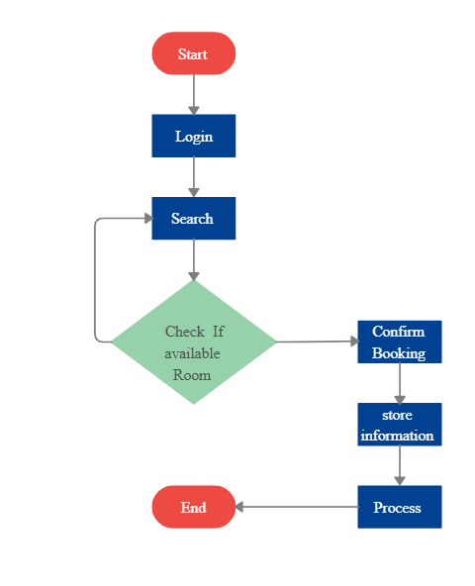

Fig.1 Flowchart of Hotel Management System

**Technical Details**

The project is developed using Python programming language with the tkinter and mysql libraries. The project code is organized into a class named "HMS" which contains the modules of room , details and customer. Customer module basically contain all information about customer for authentication it takes customer information like aadhar card etc.Room module contains information about room and through details module we can see which rooms are occupied and which are free to assigned.Through login module we will enter to the system and through logout module we can exit from system.

**Code:**

from tkinter import *

from PIL import Image,ImageTk

from customer import cust_window

from room import room_book

from details import detailsroom

class HMS:

def __init__(self,root):

self.root=root

self.root.title("Hotel Management System")

self.root.geometry("1550x800+0+0")

# -------------1st img---------------

img1=Image.open(r"C:\Users\admin\Desktop\SE PRJ\photos\francesca-saraco-_dS27XGgRyQ-unsplash.jpg")

img1=img1.resize((1550,140),Image.Resampling.LANCZOS)

self.photoimg1=ImageTk.PhotoImage(img1)

lblimg=Label(self.root,image=self.photoimg1,bd=4,relief=RIDGE)

lblimg.place(x=0,y=0,width=1550,height=140)

# ----------------logo--------------

img2=Image.open(r"C:\Users\admin\Desktop\SE PRJ\photos\vecteezy_vector-illustration-logo-grand-hotel-boutique-vintage-design_13087536.jpg")

img2=img2.resize((230,140),Image.Resampling.LANCZOS)

self.photoimg2=ImageTk.PhotoImage(img2)

lblimg=Label(self.root,image=self.photoimg2,bd=4,relief=RIDGE)

lblimg.place(x=0,y=0,width=230,height=140)

# --------------title--------------

lbl_title=Label(self.root,text="Hotel Management System",font=("times new roman",40,"bold"),bg="black",fg="gold",bd=4,relief=RIDGE)

lbl_title.place(x=0,y=140,width=1550,height=50)

#-----------frame------------------

main_frame=Frame(self.root,bd=4,relief=RIDGE)

main_frame.place(x=0,y=190,width=1550,height=620)

# --------------menu--------------

lbl_menu=Label(main_frame,text="Menu",font=("times new roman",20,"bold"),bg="black",fg="gold",bd=4,relief=RIDGE)

lbl_menu.place(x=0,y=0,width=230)

#-----------btn frame------------------

btn_frame=Frame(main_frame,bd=4,relief=RIDGE)

btn_frame.place(x=0,y=35,width=228,height=190)

cust_btn=Button(btn_frame,text="CUSTOMER",command=self.cust_det,width=22,font=("times new roman",14,"bold"),bg="black",fg="gold",bd=0,cursor="hand1")

cust_btn.grid(row=0,column=0,pady=1)

room_btn=Button(btn_frame,text="DETAILS",command=self.room_det,width=22,font=("times new roman",14,"bold"),bg="black",fg="gold",bd=0,cursor="hand1")

room_btn.grid(row=1,column=0,pady=1)

details_btn=Button(btn_frame,text="ROOM",command=self.details_room,width=22,font=("times new roman",14,"bold"),bg="black",fg="gold",bd=0,cursor="hand1")

details_btn.grid(row=2,column=0,pady=1)

logout_btn=Button(btn_frame,text="LOGOUT",command=self.logout,width=22,font=("times new roman",14,"bold"),bg="black",fg="gold",bd=0,cursor="hand1")

logout_btn.grid(row=4,column=0,pady=1)

# -------------right side image-------------

img3=Image.open(r"C:\Users\admin\Desktop\SE PRJ\photos\louis-hansel-wVoP_Q2Bg_A-unsplash.jpg")

img3=img3.resize((1310,590),Image.Resampling.LANCZOS)

self.photoimg3=ImageTk.PhotoImage(img3)

lblimg1=Label(main_frame,image=self.photoimg3,bd=4,relief=RIDGE)

lblimg1.place(x=225,y=0,width=1310,height=590)

#--------------down images-------------------

img4=Image.open(r"C:\Users\admin\Desktop\SE PRJ\photos\qui-nguyen-giL2fHNr3Lc-unsplash.jpg")

img4=img4.resize((230,210),Image.Resampling.LANCZOS)

self.photoimg4=ImageTk.PhotoImage(img4)

lblimg2=Label(main_frame,image=self.photoimg4,bd=4,relief=RIDGE)

lblimg2.place(x=0,y=225,width=230,height=210)

img5=Image.open(r"C:\Users\admin\Desktop\SE PRJ\photos\rachel-park-hrlvr2ZlUNk-unsplash.jpg")

img5=img5.resize((230,190),Image.Resampling.LANCZOS)

self.photoimg5=ImageTk.PhotoImage(img5)

lblimg3=Label(main_frame,image=self.photoimg5,bd=4,relief=RIDGE)

lblimg3.place(x=0,y=420,width=230,height=190)

def cust_det(self):

self.new_window=Toplevel(self.root)

self.app=cust_window(self.new_window)

def room_det(self):

self.new_window=Toplevel(self.root)

self.app=room_book(self.new_window)

def details_room(self):

self.new_window=Toplevel(self.root)

self.app=detailsroom(self.new_window)

def logout(self):

self.root.destroy()

if __name__=="__main__":

root=Tk()

obj=HMS(root)

root.mainloop()

**Output:**

**1. Home Page**

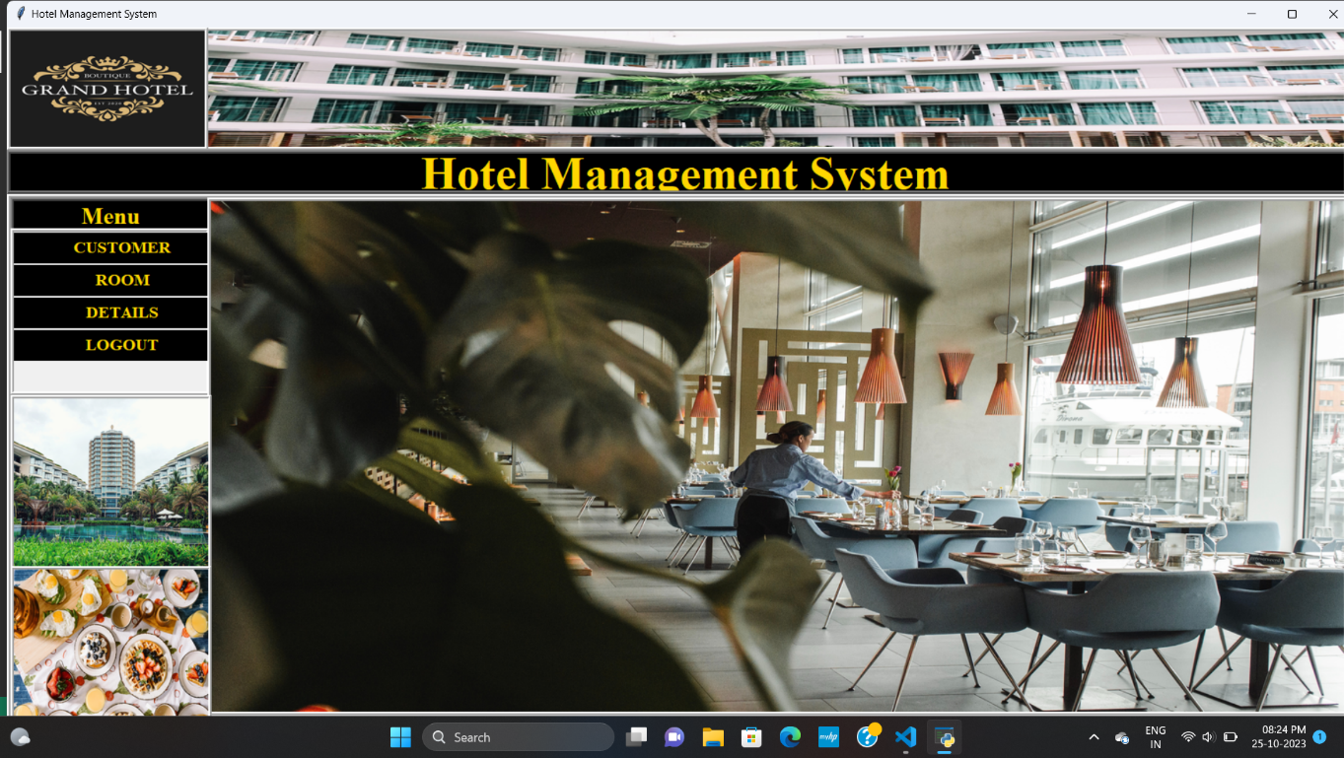

Fig.1 Home page of Hotel Management System

**2. Deleting one customer from Customer Details.**

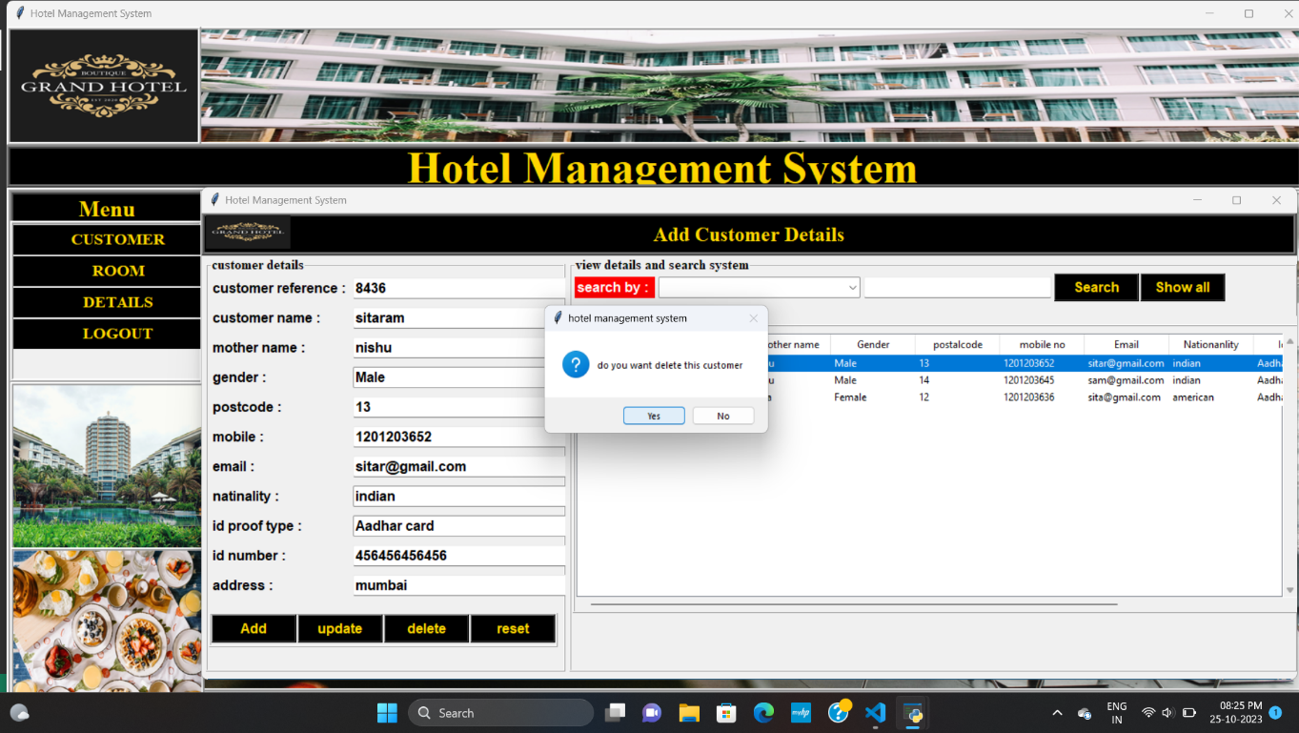

Fig. 2 Deleting one customer Details

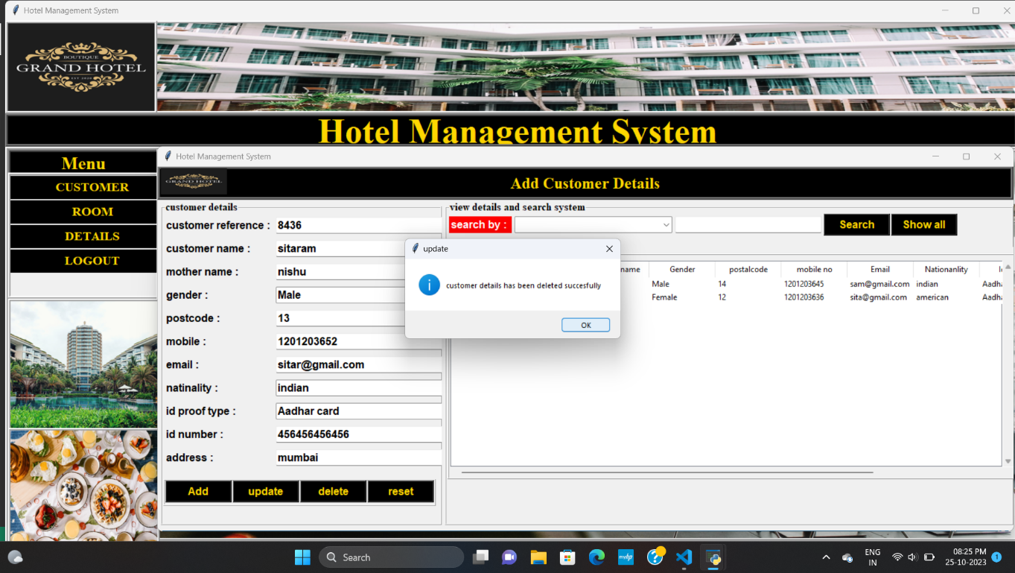

Fig.3 Customer Deleted Successfully

**3. Generating Bill for customer and Updating the Booking List** 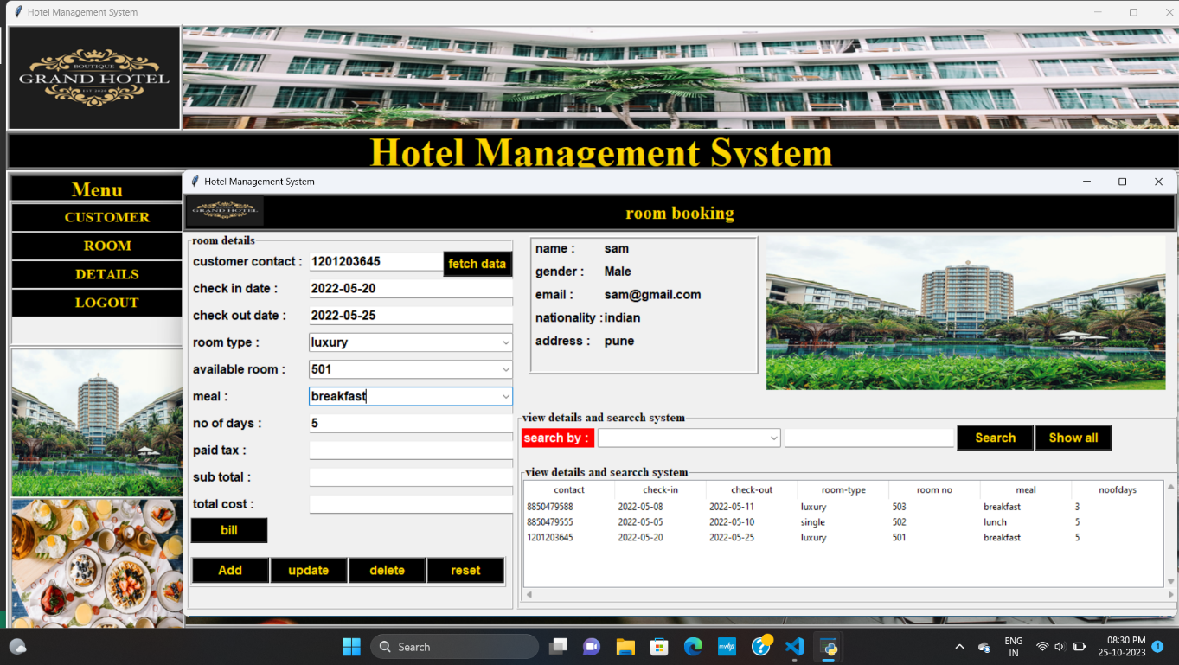

Fig.4 Retrieving Customer Data

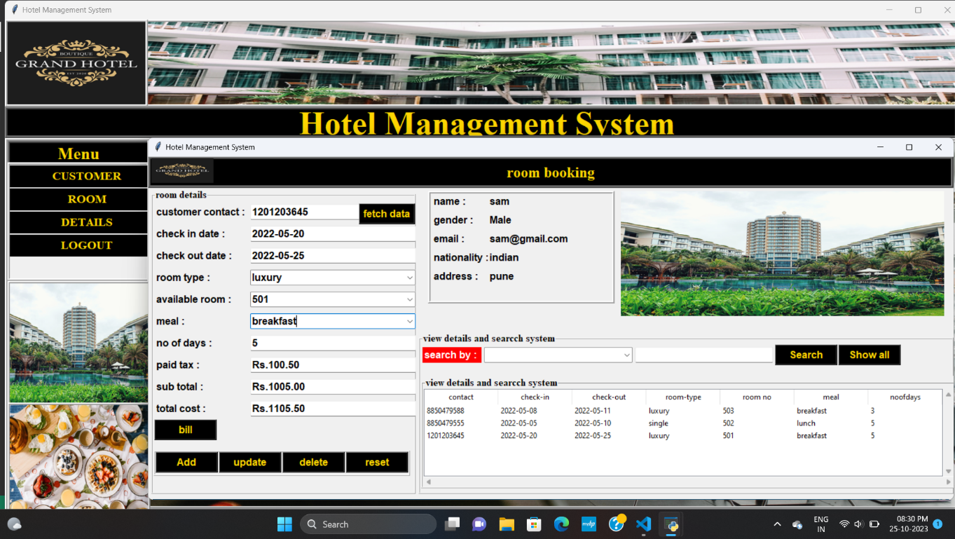

Fig.5 Generating bill and Total Cost

**4. Adding one room in Rooms List**

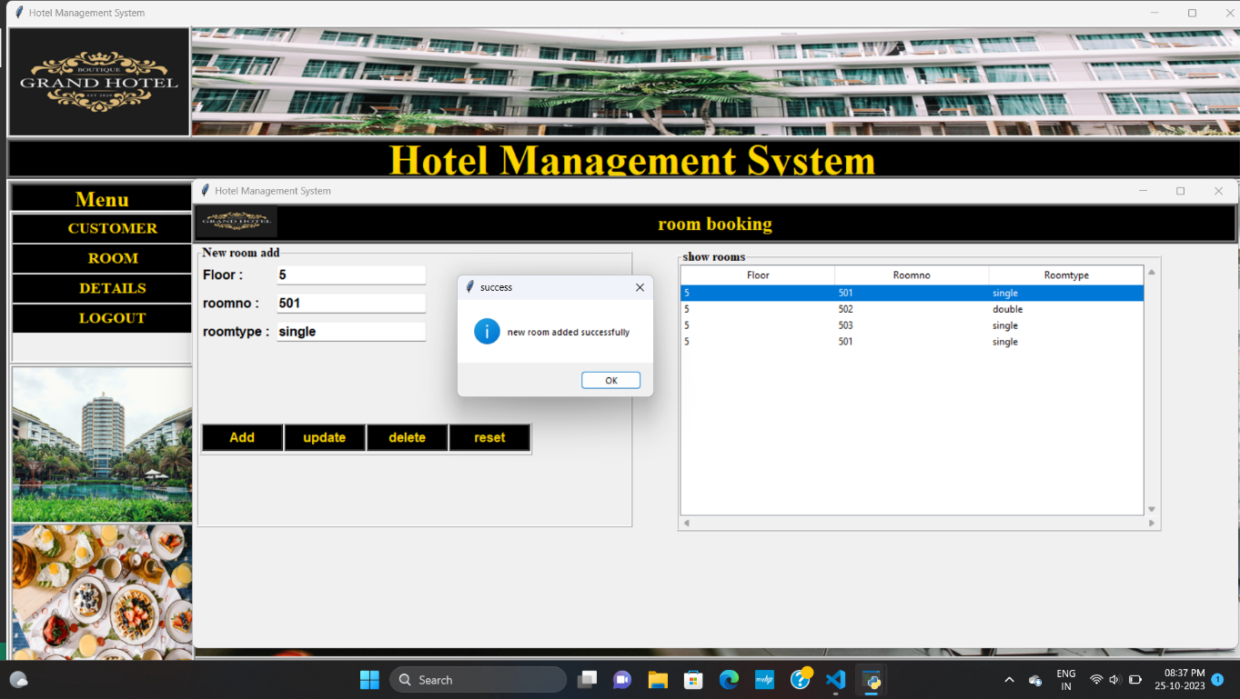

Fig.6 Room Added Successfully

**Result**

Hotel Management System is a Web-portal Development Company specializing in providing custom solutions for small businesses. We strive to build solutions to your specific needs to get the job done right the first time. We pay special attention to the ease of use and utilize the latest technology. This system is developed exclusively for the people . It provides facilities to the user with user friendly modules with sub modules. This system is developed in an understandable approach which can be easier to the layman of the computers.

**Conclusion**

This project is designed to meet the requirements of Online Hotel Management. It has been developed in JSP, Servlets keeping in mind the specifications of the system. For designing the system we have used simple data flow diagrams. Overall the project teaches us the essential skills like: Using system analysis and design techniques like data flow diagram in designing the system. Understanding the database handling and query processing.

HOTEL MANAGEMENT SYSTEM is a Web-portal DevelopmentCompany specializing in providing custom solutions for small businesses.We strive to build solutions to your specific needs to get the job done right the first time. We pay special attention to the ease of use and utilize the latest technology.

This system is developed exclusively for the people . It provides facilities to the user with user friendly modules with sub modules. Thissystem is developed in an understandable approach which can be easier to the layman of the computers. This system is developed totally GUI based and with smart links.

This project is designed to meet the requirements of Online HotelManagement. It has been developed in JSP, Servlets keeping in mind the specifications of the system. For designing the system we have used simple data flow diagrams.Overall the project teaches us the essential skills like: Using system analysis and design techniques like data flow diagram in designing the system. Understanding the database handling and query processing.

**References**

1. Smith, J. (2019). "Design and Implementation of a Hotel Management System." International Journal of Computer Science and Information Technology, 7(3), 45-58.

2. Brown, A. (2020). "Guest Reservation and Booking Systems in the Hospitality Industry." Journal of Hospitality and Tourism Technology, 11(2), 123-137.

3. HotelTech Solutions. (2022). "Hotel Management System Software." Retrieved from https://www.hoteltechsolutions.net/hotel-management-system-software

4. Johnson, M. (2018). "Emerging Trends in Hotel Technology." In Proceedings of the International Conference on Hospitality Technology (pp. 87-102). Springer.

5. Hotel Management System User Manual. (2021). ABC Software Solutions, Inc.